

Feature 1: Currency Conversion

ST10081245 ST10145067 ST10264009 ST10397162 ST10368647

Functionality:

* Users can select a base currency from a list of popular options such as **USD (US Dollar), EUR (Euro), GBP (British Pound)**, and more.
* The amount to be converted can be entered manually through a clean, intuitive input interface.
* Upon confirmation, the app fetches **real-time exchange rates** (from an integrated API or local update source) and calculates the equivalent value in **South African Rand (ZAR)**.
* Each conversion performed by the user is **stored in a local history log**, enabling users to revisit past conversions for financial records, comparison, or reference.
* The feature includes **input validation** to prevent errors (e.g., negative values or invalid currency selection).

Benefits:

* Helps users make informed budgeting decisions for international purchases or travel expenses.
* Useful for freelancers or remote workers dealing with multi-currency income.
* Adds precision to expense entries by converting them accurately into ZAR.
* Promotes transparency and traceability with a historical conversion log.

Feature 2: Expense Reminders

Functionality:

* While recording an expense, users have the option to **attach a reminder** to that specific transaction.
* Reminders can be configured as **one-time notifications** or **recurring events** ideal for monthly rent, weekly loan payments, or yearly subscriptions.
* Users receive **automated alerts** through the device's notification system at the scheduled time or date.
* Reminders can be edited or deleted easily, offering flexibility and control as financial plans change.
* The reminder system is designed to be lightweight and seamlessly integrated into the existing expense entry workflow.

Benefits:

* Reduces the risk of **missed payments**, which can lead to additional charges or service interruptions.
* Encourages consistent **financial planning and organization**.
* Enhances user confidence in managing day-to-day and long-term obligations.
* Ensures that recurring expenses like subscriptions or bills are always accounted for on time.
* Makes the app not just a tracker but a **personal finance assistant**.

**App Icon:**



GitHub Link:

<https://github.com/ChloeNaidoo/PROG7313-POE.git>

Video Link:

<https://youtu.be/fqaytOSxHrA>

Part 1 Research link:   
[POE_Part1_PROG7313_404 Solutions.docx](https://1drv.ms/w/c/43b6eead7690b636/EdOOPLYGA3VPpXgYIFZ8L5MBKMerRaVxOcF9N0UWfLRF6Q?e=aa4f7k)

Part 1 Planning and Design:  
[PROG7313 POE.docx](https://1drv.ms/w/c/43b6eead7690b636/Eeb96J-pzExPq3UTcfzovrMBfDptdnvYxZFZT5G_Qz3rZA?e=IwfG9C)

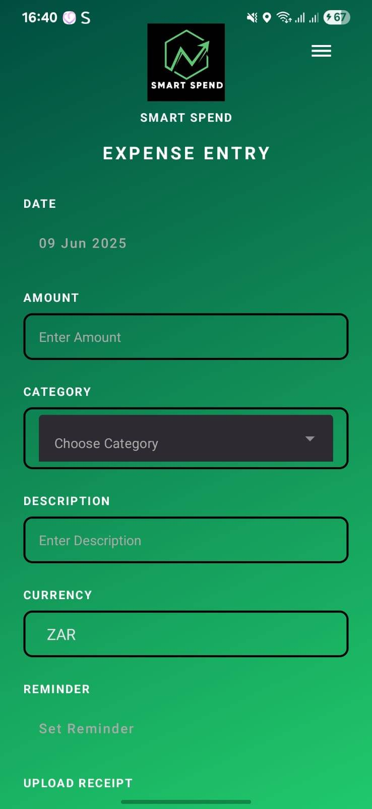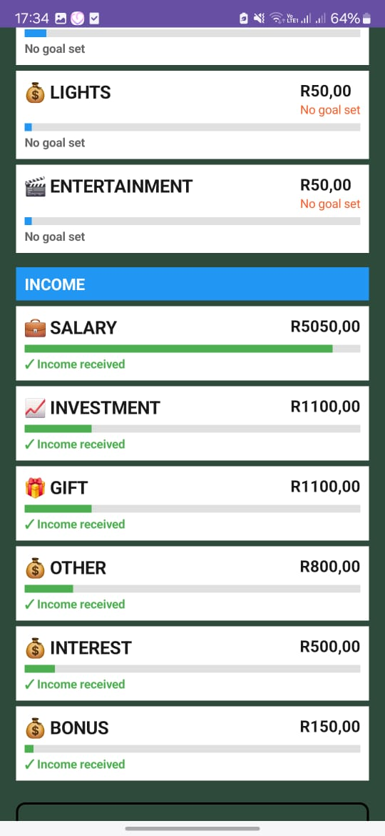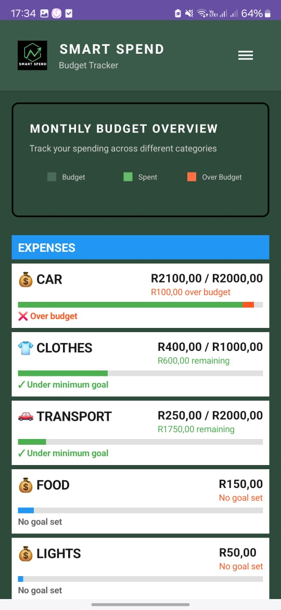

User Interfaces:

Expense Entry

Min and Max Graph feature

Income Entry

Login

Logout

Income

Expense

Navigation

Set Goal

Tracking Spending Graph Feature

Total Transaction

Home page

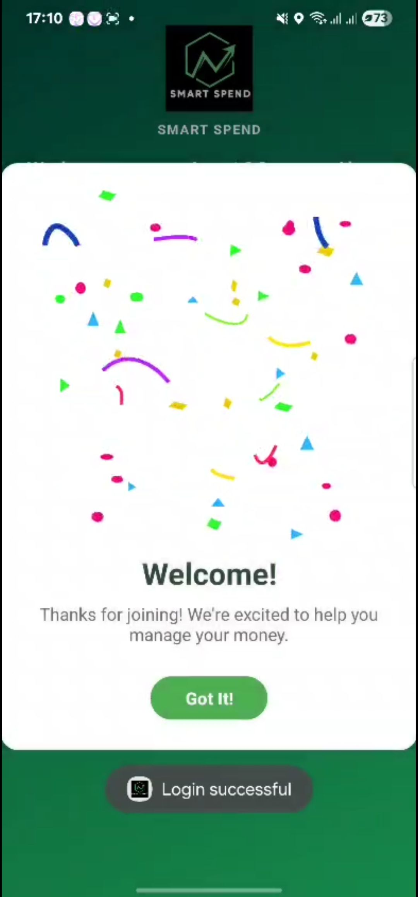

First Gamification

Reminder Feature

Currency Converter feature